HAND to hand
VOLUNTEER
Guidelines

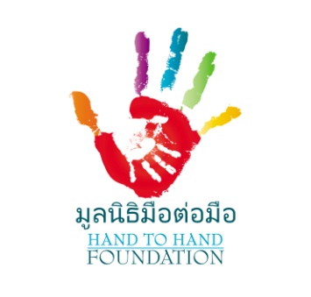

WELCOME TO HAND TO HAND
To assist you to enjoy your time with Hand to Hand and ensure you are fully informed of the foundation’s procedures, please read the following guidelines.
Code of Conduct:
- The safety of children is of first importance and the responsibility of all adults. Report any incidents or issues that arise with a member of the Hand to Hand staff.
- At no time should a volunteer be alone with a child.
- Never physically discipline or show aggression to a child.
- Do not engage in inappropriate physical activity with a child.
- Do not have inappropriate conversations with a child. If a child confides information to you of a physical or sexual concern alert a staff member immediately.
- Never give the children medication, money, food, lollies or other items without the approval of a staff member.
- No photos of children are allowed without the express permission of a member of the Hand to Hand staff.
- Please follow the directions of staff members at all times to ensure the safety of the children. If you are unsure of anything, please ask a staff member for clarification.
- Please ensure you read the Child Protection Policy.
Personal Responsibilities:
You cannot visit any of the Hand to Hand ministries (e.g.: prison, slum, hospital) without a Hand to Hand staff member.
You are responsible for your own transport and accommodation costs.
Never transport Hand to Hand children in/on your own vehicle.
Maintain Christian values at all times.
Dress Code:
Comfortable and casual dress is appropriate.
- Shirts/ T shirts with sleeves. (No tank tops or singlet.)
- Knee length shorts; long pants; dress or skirt.
- Clothing that covers the three B’s e.g. belly, bottom and breasts.
Social Media:
You may not publish photos of children on the internet without the permission of the Hand to Hand staff.
Privacy:
Personal information about children, staff or volunteers must be kept confidential. If a child shares information of concern e.g. physical/sexual/emotional abuse, report it immediately to a staff member. For information regarding the collection of your personal information by Hand to Hand please read the Privacy Policy.
Toilet/Bathroom facilities:
All volunteers must use the staff toilet/bathroom located upstairs. At no time should a volunteer accompany a child to the bathroom or use the children’s toilets.
Kitchen Facilities:
Tea and coffee are available in the staff kitchen. Please return wash and dry cups/mugs after use. A fridge is also provided for your cold drinks/snacks.

Smoking/alcohol/illegal drugs
Smoking is not permitted within the Hand to Hand premises. Please smoke outside the fence and at least 5 metres from the gate. Drinking of alcohol and use of recreational drugs is not permitted on the premises.
First Aid:
In case of accident assist the child and alert a staff member. A first aid kit is located in the inside storeroom cupboard.
Fire Safety:
In case of a fire call out Fire, Fire, Fire 3 times. Assist children to evacuate the building. Fire extinguishers are located; at the front entrance, in the kitchen, inside store room and upstairs classroom. Please take a moment to familiarise yourself with their location.

If you have any questions regarding the practices at Hand to Hand please ask a staff member. Please feel free to offer any suggestions, as we value your assistance in improving our best practice.
Thank you for giving your time to volunteer with us. We trust you have a fulfilling experience.
Contact information:
Please ensure your contact details are recorded with administration.
If you need to contact Hand to Hand for any reason please phone
Margie: 089-0936067 or Pai: 087-0629304

